WordPress for beginners

* How to login? Site/wp-login.php (emj tebI9068.)
* Already logged in? site/wp-admin
* Add categories first, and then add them to the posts
* Wordpress sorts posts by the most recent ones
* Page’s don’t show the date were created, posts do
* Theme: color, fonts, layout (columns)
* To add a new theme I had to go to “Network admin”
* Every theme has different ‘diplay locations’ for menus
* Every theme let you customize different amount of features
* If enter is pressed in the posts editor, an new BLOCK is created
* 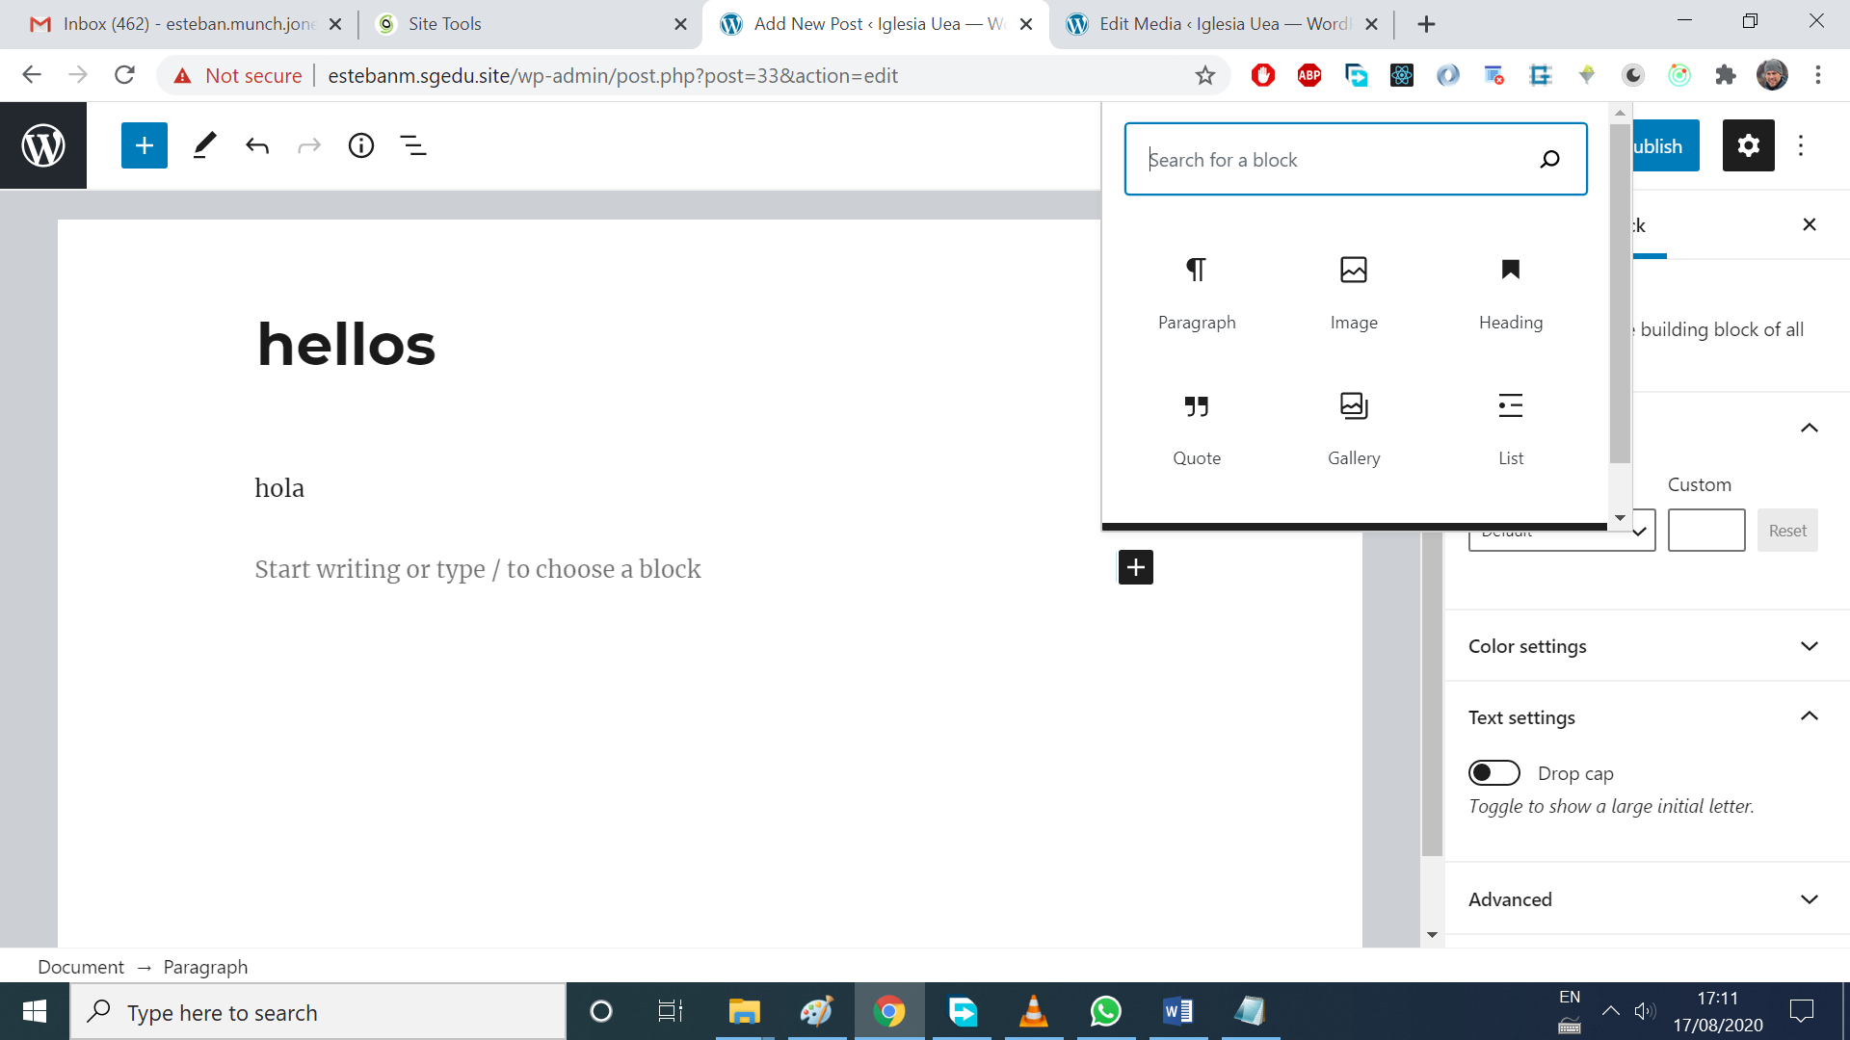
* The code can be viewed:
* 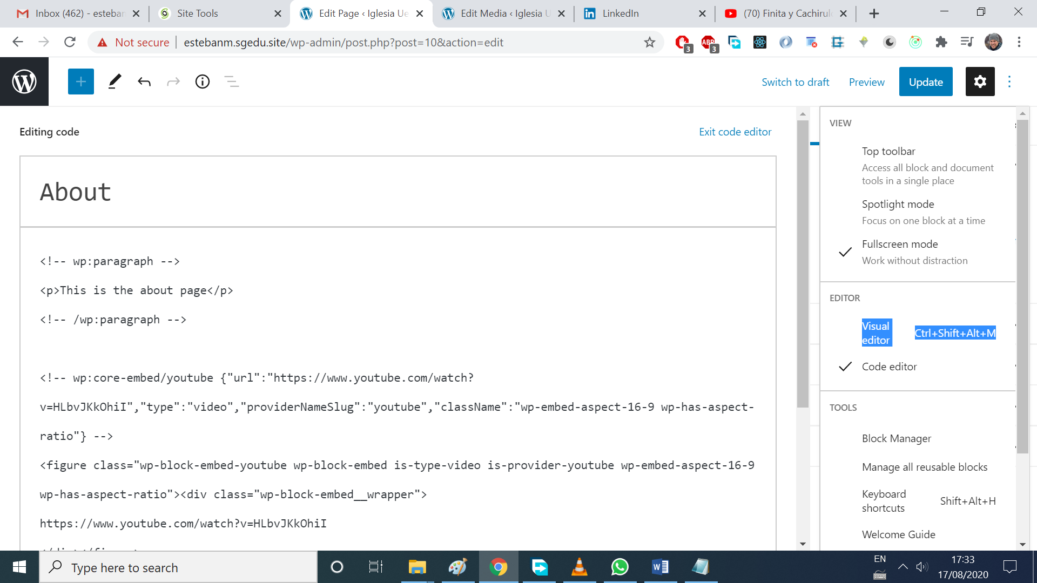
* When generating the link in youtube, there are options about titles, controls, etc
* 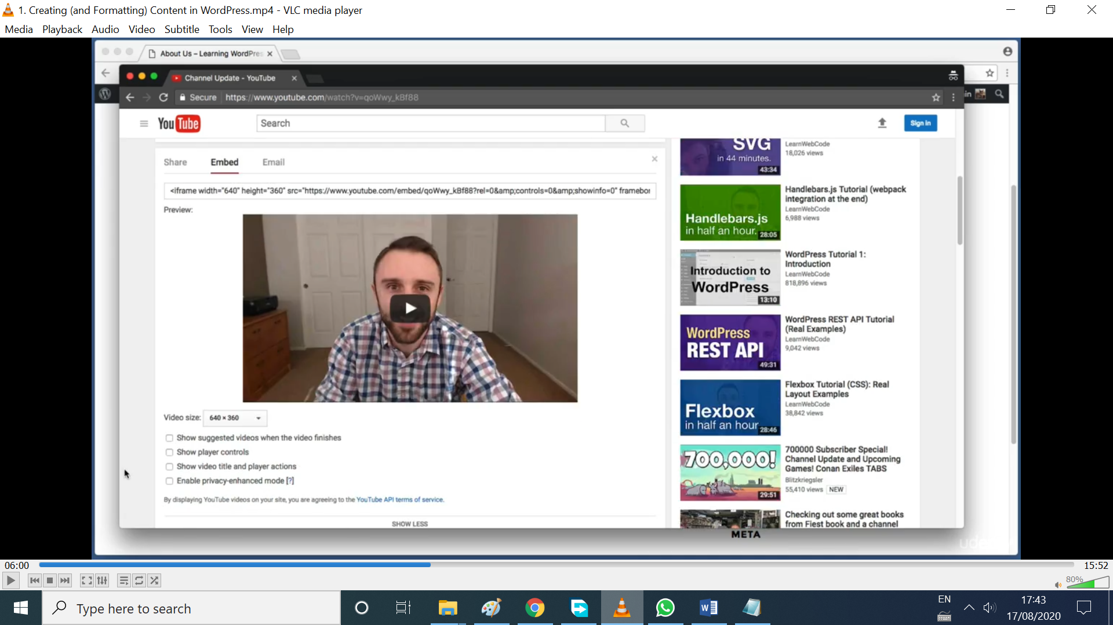
* Subpages: the indentation shows it’s a subpage
* 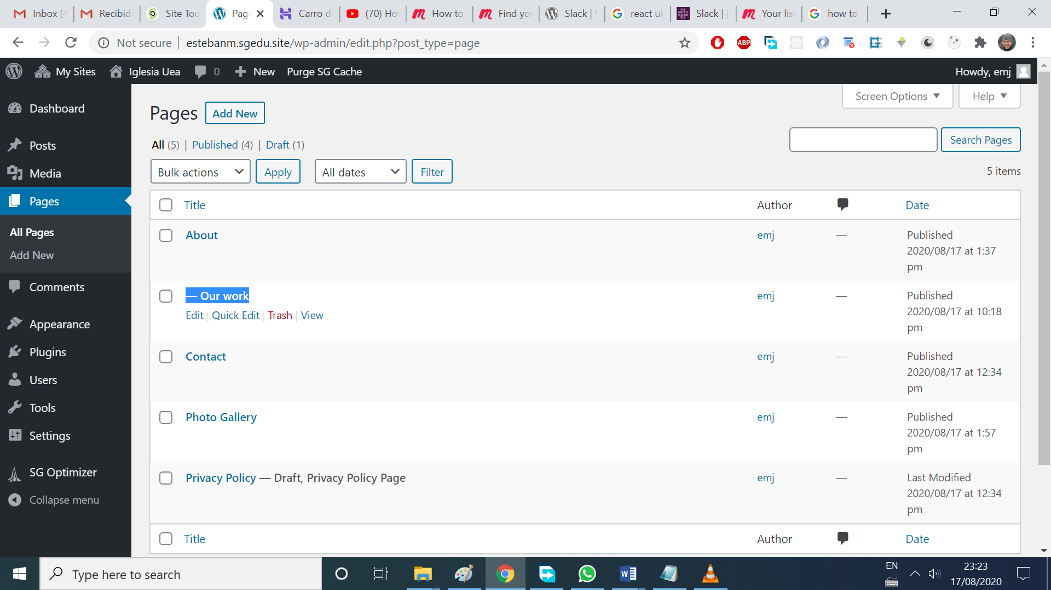
* To see the block options, click the settings engranaje icon
* A Modal is also called a light box. E.g a carousel modal with a backdrop, can be done with a plugin ! ‘responsive lightbox’ one is great
* How to customize the home page? Because it shows all the posts
* Solution: create a welcome page, and blog page (empty one)
* 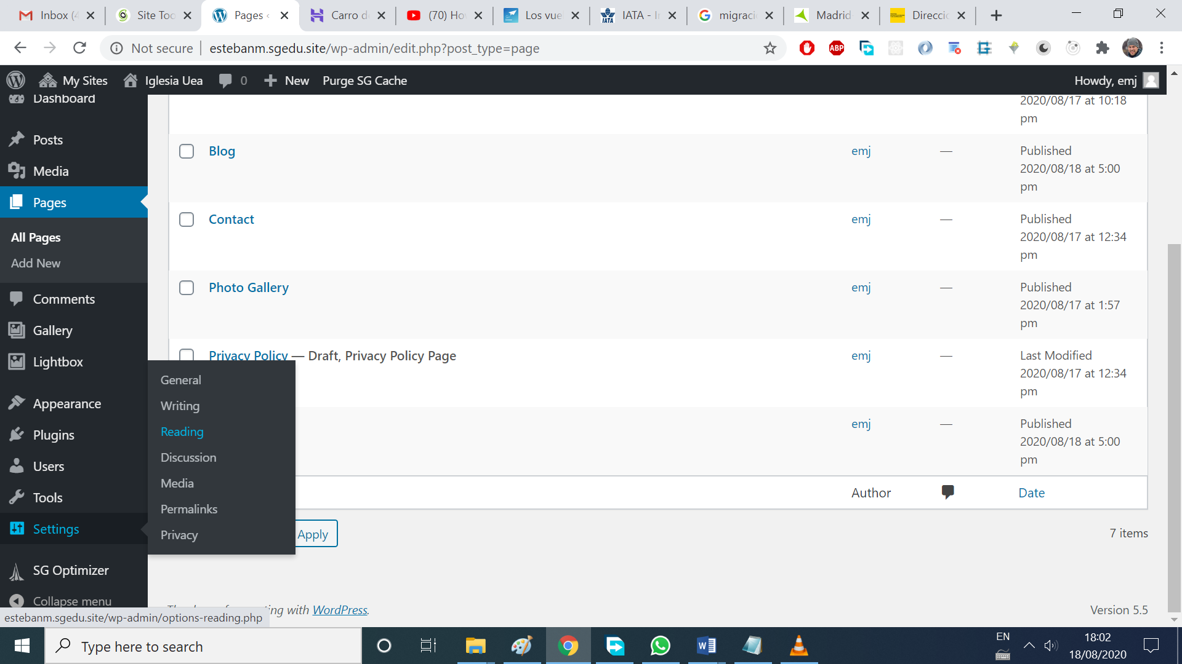

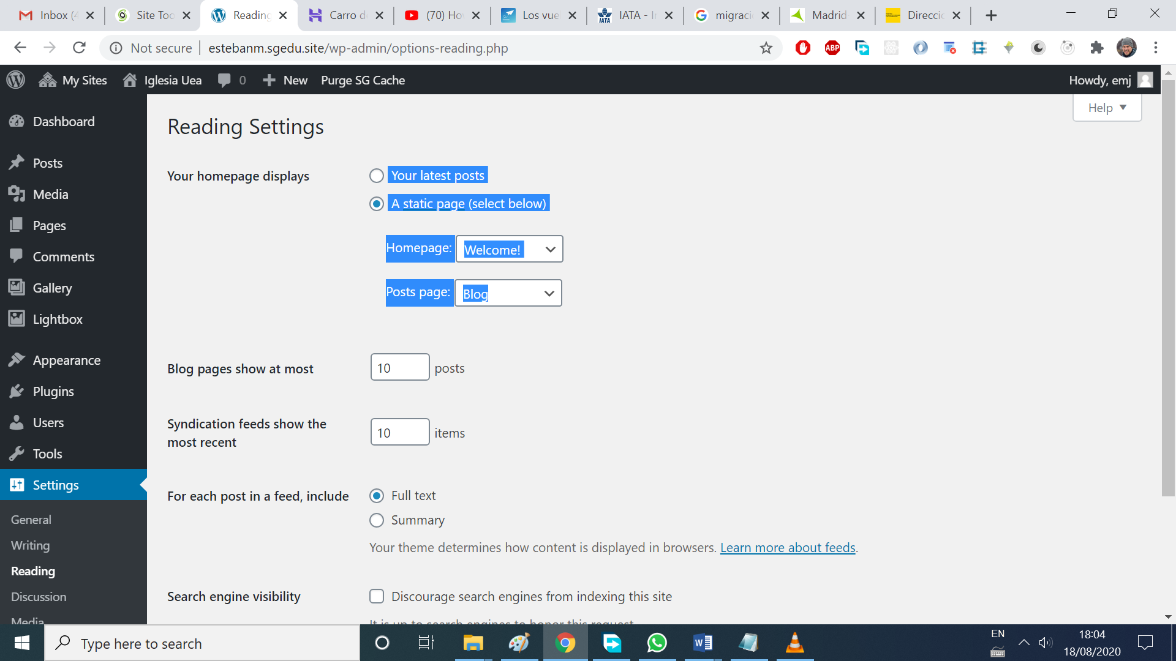

* To have all the classic options:
* 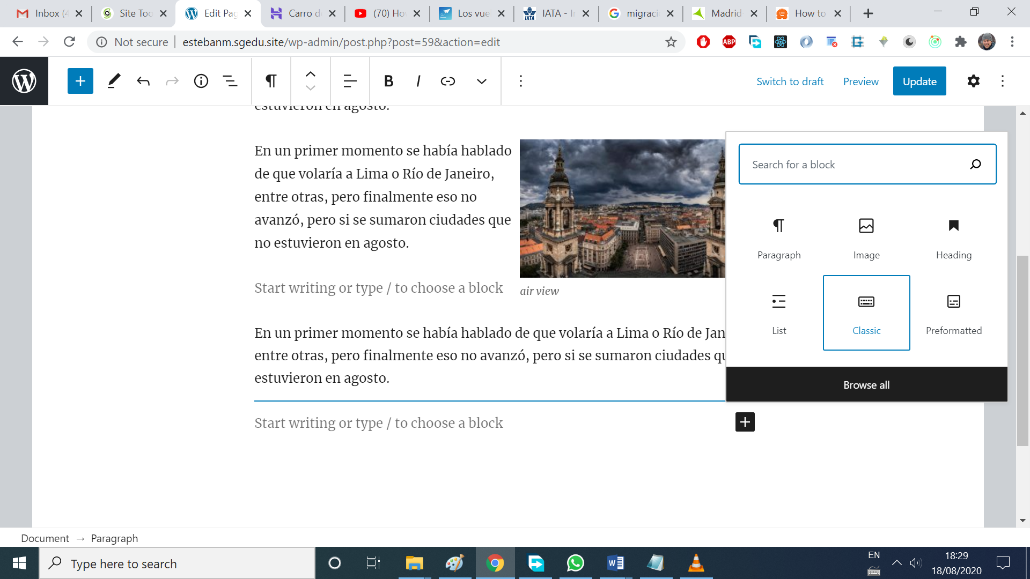
* There’s a block called classic!

Section 5 Posts

* What is a featured image? An image associated with the post.
* Advantages of featured image over normal image: spans the full width. It’s a good idea to crop the f.image and make it shorter.
* What is a read more tag? Use the classic block, and add a ‘read more tag’
* What is an exerpt? Excerpt is an optional text associated to a Post. Most of the time, it is used as the **Post summary**.
* Here is the exerpt:
* 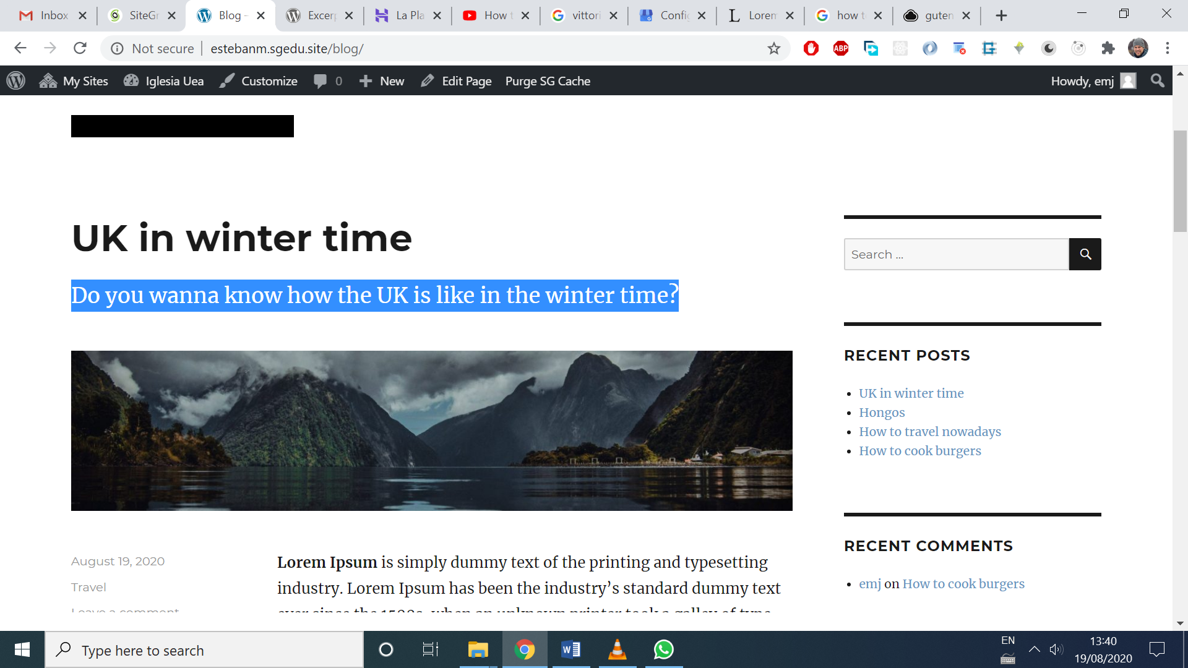
* Trackbacks and pingbacks are like comments to let us know where how the user reached our post
* If I disable settings/discussions/comments for all the posts, is not retroactive, so the old posts will still have comments activaded
* 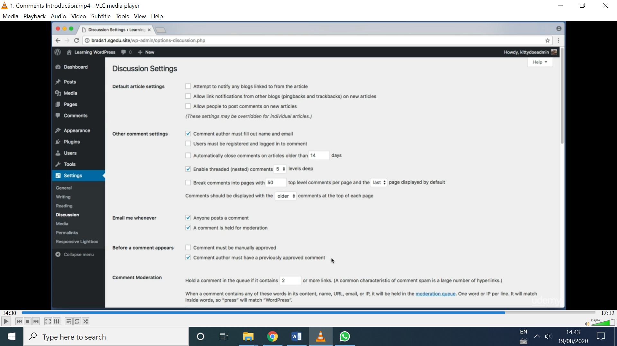
* The option selected for ‘before a comment appears’ is for approving just the first comment of a user, then there’s no need for further checks
* How to prevent spam comments?
* Akismet plugin (paid) antispam bee is a good option then
* The disqus plugin replaces the default WP commenting system
* Disqus comment system, no pude instalarlo, cadorcha total

Widgets

What are widgets? All the thins on the right column:

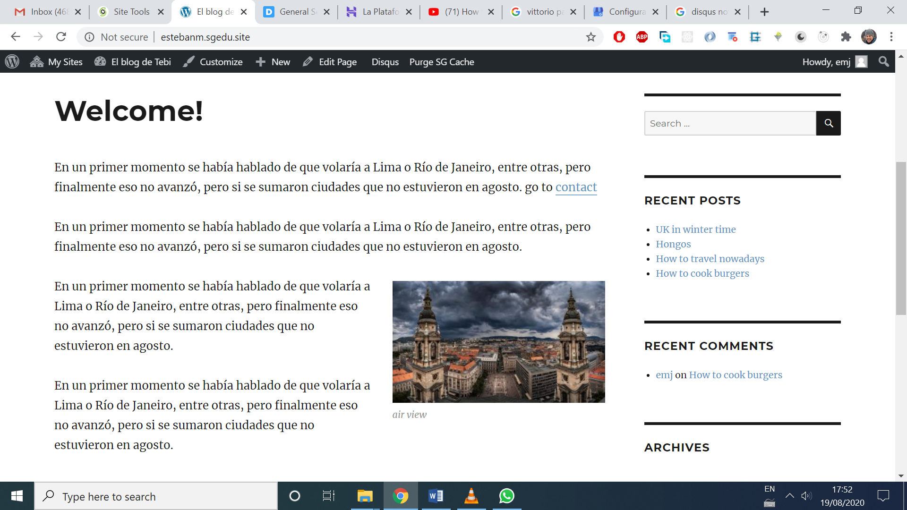

For bottom widgets, if one of them is activated, it’s take the space of bottom1 and bottom2

* Need more widgets? Add a plugin
* Wanna show just the latest Food posts? Install **Category Posts Widget plugin**
* **Want social media icons? Install Simple Social Icons plugin**
* **Wanna remove the right side column? Delete all the widgets**
* **To add google maps, just go to maps.google.com and share a location,with embed code**
* **And past it with the code editor**
* **Need a contact form? Install Contact Form 7**
* Copy and paste the shortcode in Contact page
* Add captcha to prevent spam
* 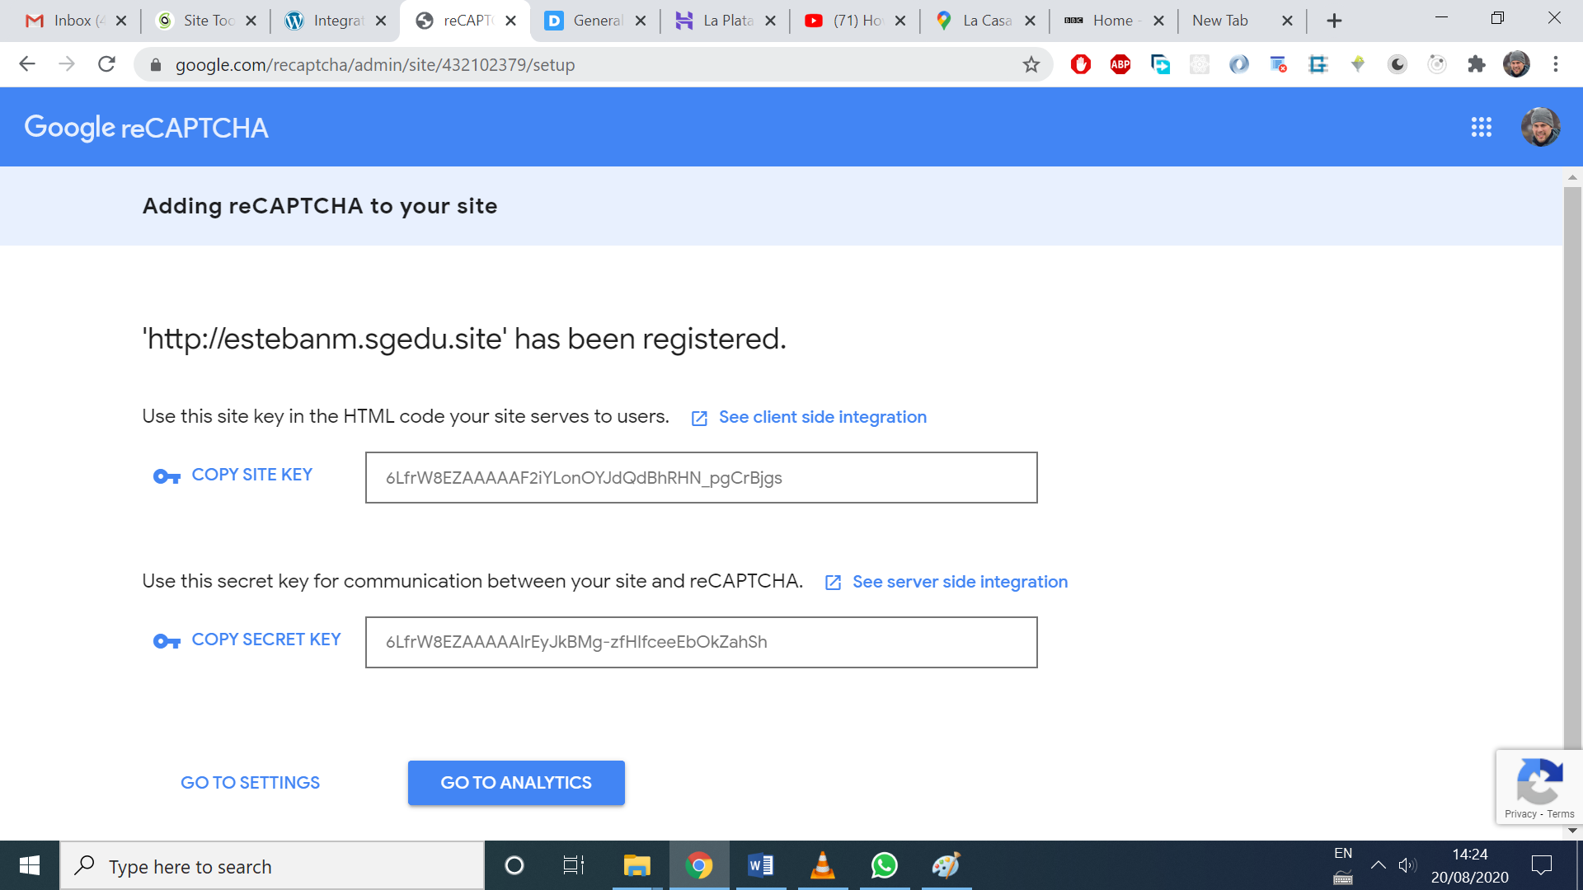
* How to save sent messages on the database?
* Use Flamingo. Saves comments and messages
* The user’s comments can be improved by changing the name and adding a picture
* 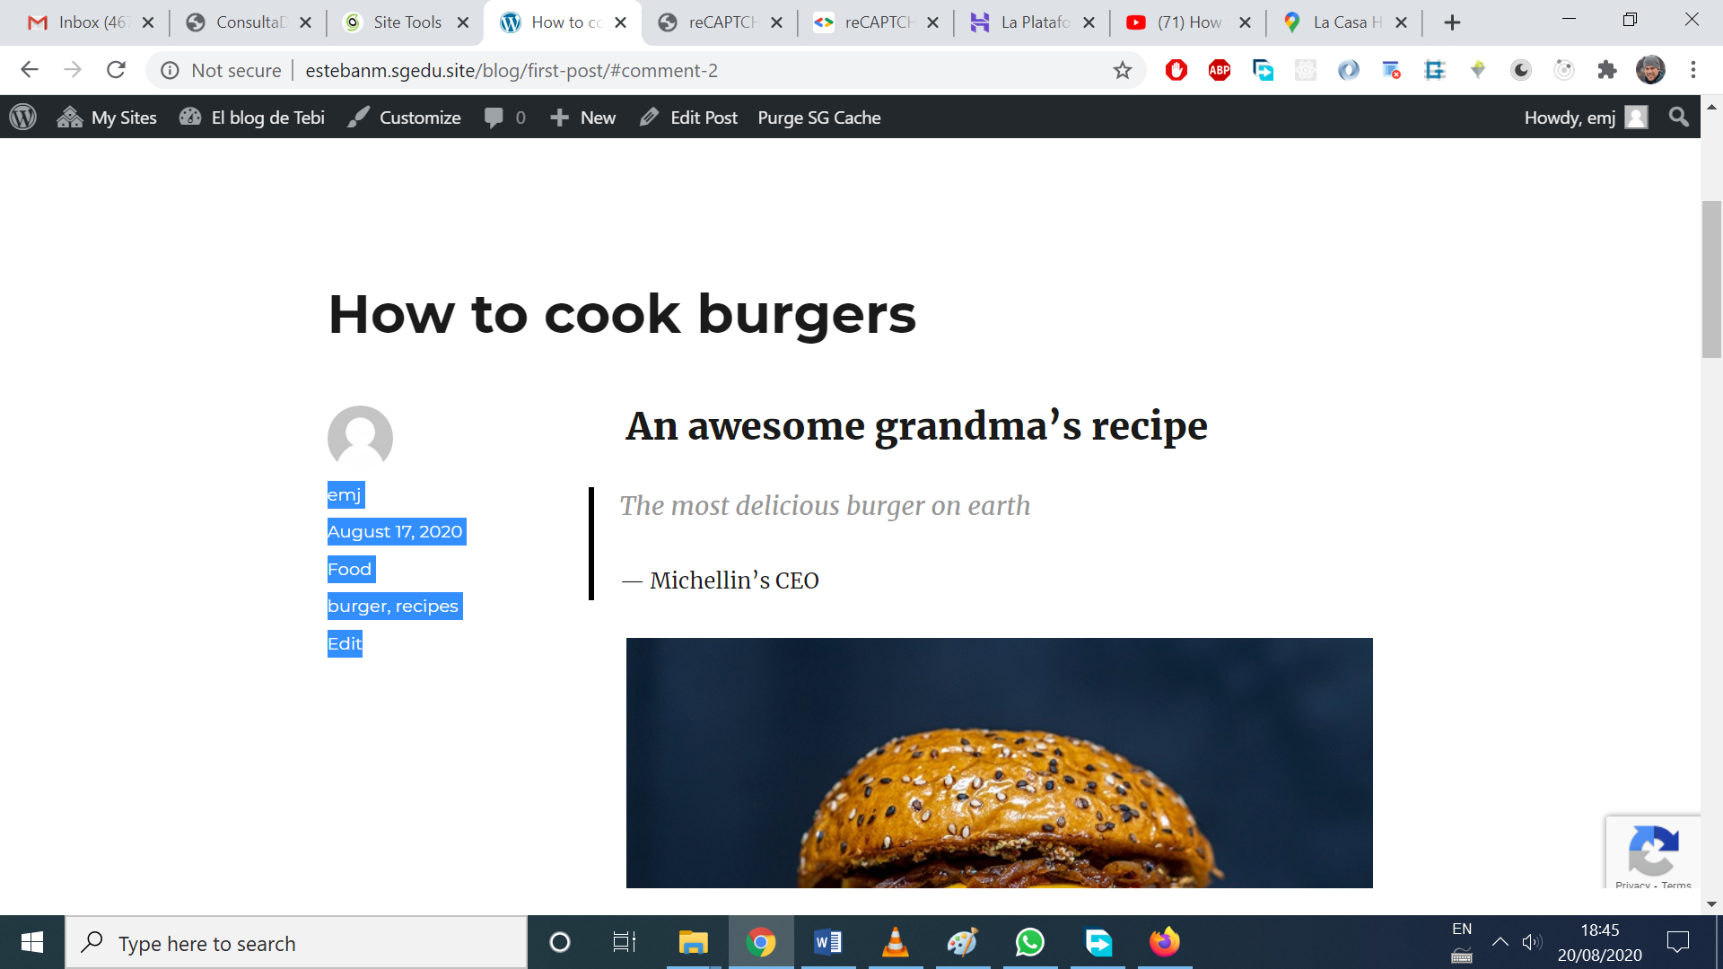
* To add the image set up a gravatar account
* The email account used in the wordpress site must the same as the gravatar.com one
* Roles: admin, editor, collaborator, subscriber
* What is a permalink? Is a permanent link
* 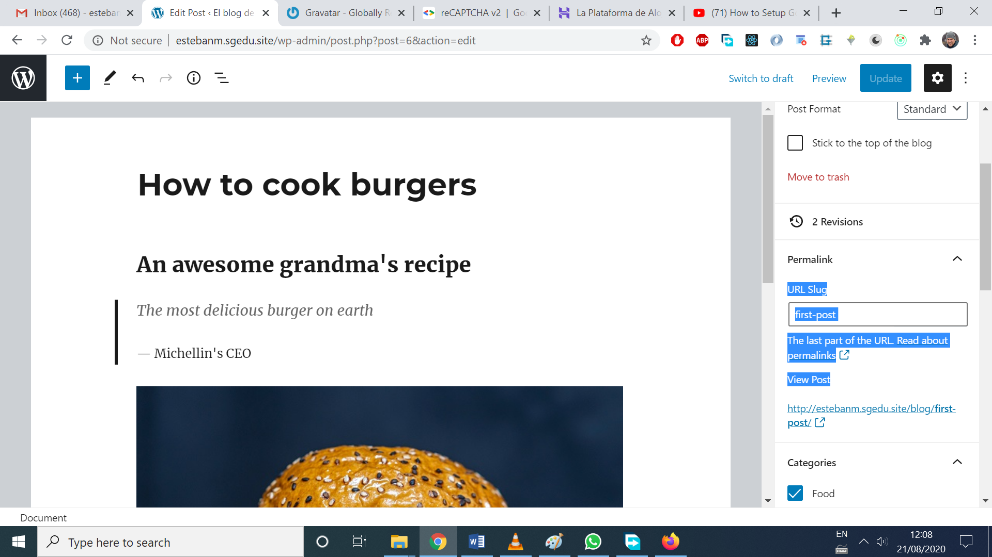
* For the burger post, it’s ‘first-post’, that slug doesn’t change, so the full path never changes and can be safely shared in social media and not return a 404 page. <http://estebanm.sgedu.site/blog/first-post/>
* To change the permalink structure, go to settings/permalinks
* 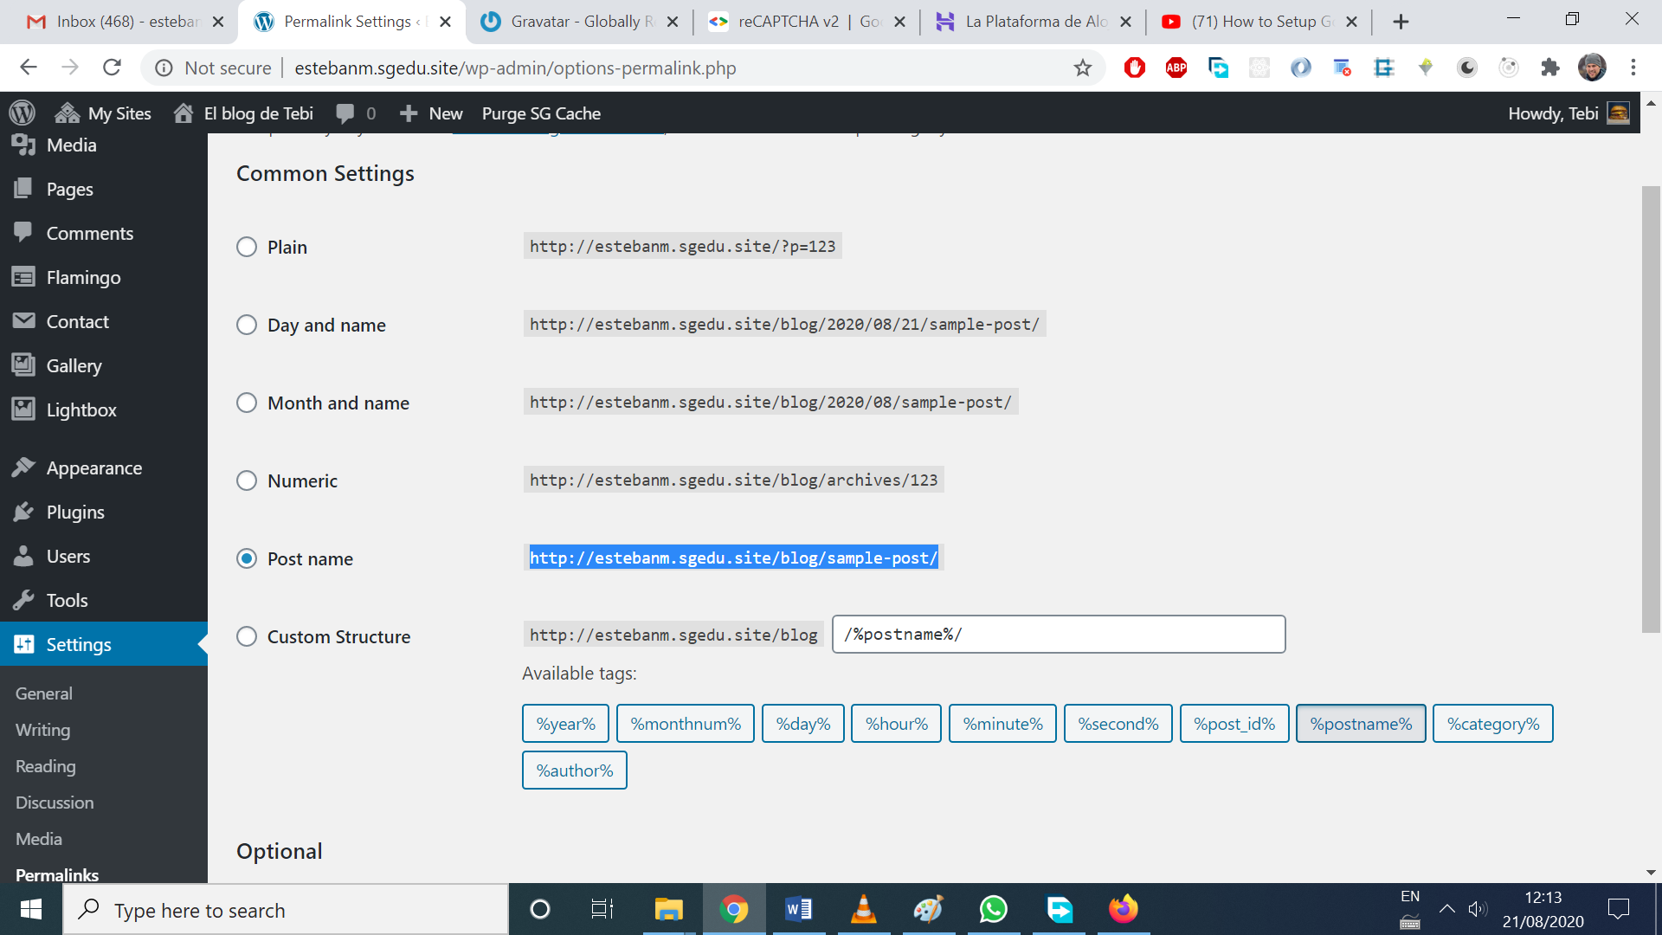
* There’s a /blog in the full path because /blog page was set to be the posts page
* 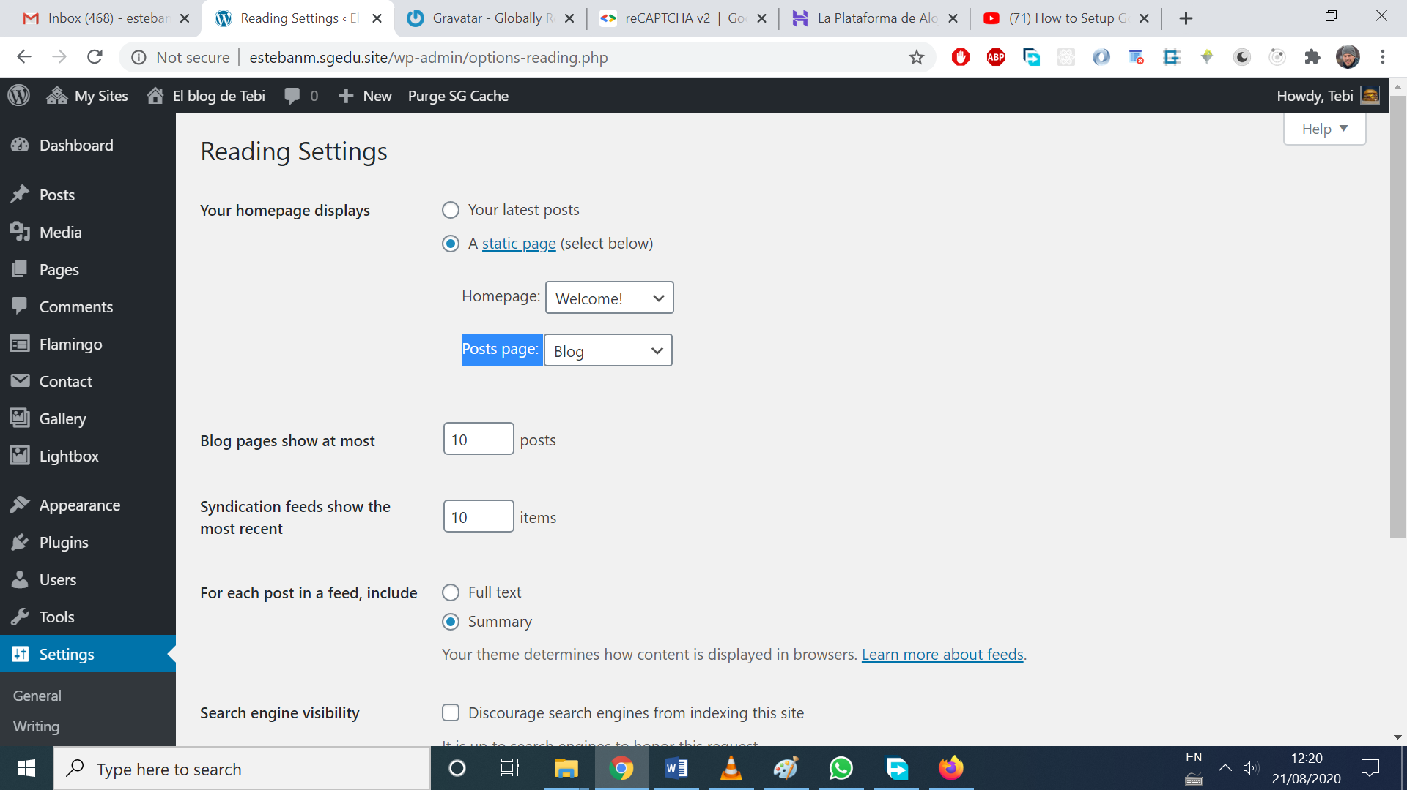
* What is Pagination? When showing just a max number of posts in a page (eg 10)
* Look at the previous photo, ‘blog pages show at most’ and change the number
* Wanna move the WP site? All-in-one-wp-migration plugin
* Export then import.
* Extra step: login to wp site, and change the permalinks url options, an change them back again, and click save, to regenerate the permalinks
* Set up services: Then, regenerate secret and site key for reCaptcha, because they were relying on an url. (do this, if the migration involved a change in the url), and change Disqus settings as well
* All the themes and plugins you can search on wordpress are free. All the premium stuff is on the vendor’s websites